DZIEŃ KOBIET

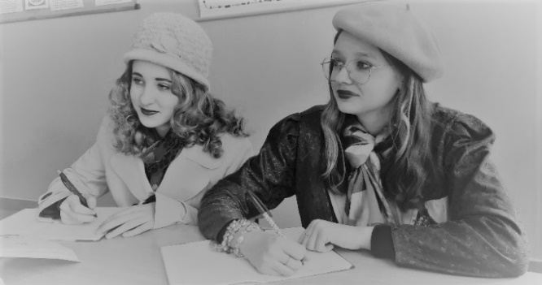
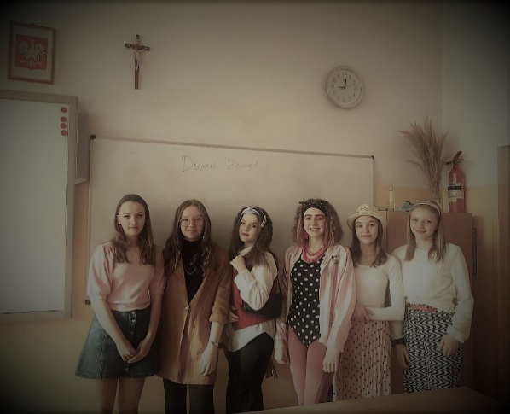
https://spborowa.edupage.org/news/?eqa=d2lkPW5ld3NfTmV3c18xX3AmbmV3c2FyY2hpdmVmPTIwMjItMDMmb2Zmc2V0X25ld3NfTmV3c18xX3A9MA%3D%3D#photos:album:1681

DZIEŃ KOBIET W ODDZIAŁACH PRZEDSZKOLNYCH

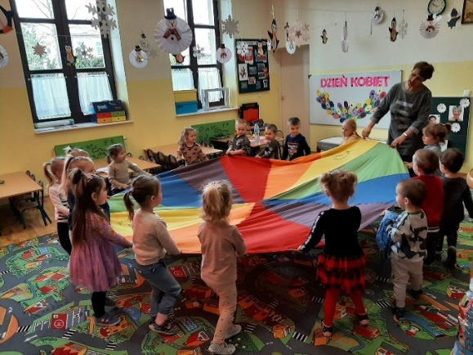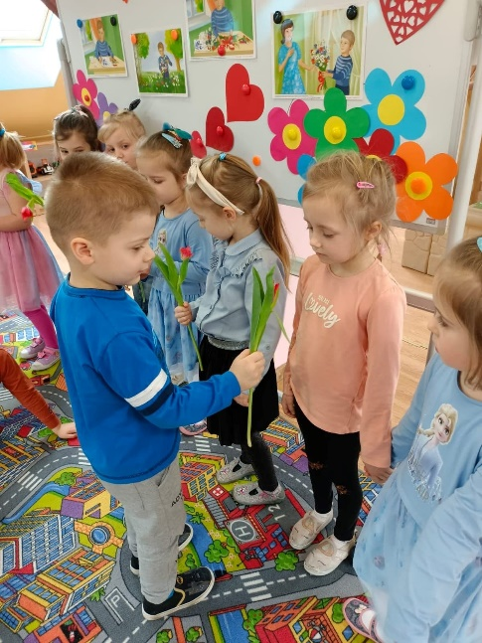
https://spborowa.edupage.org/news/?eqa=d2lkPW5ld3NfTmV3c18xX3AmbmV3c2FyY2hpdmVmPTIwMjItMDMmb2Zmc2V0X25ld3NfTmV3c18xX3A9MA%3D%3D#photos:album:1683

TYDZIEŃ POZYTYWNEGO MYŚLENIA W KLASIE III B

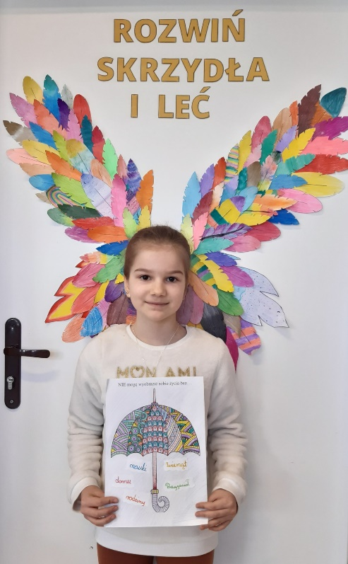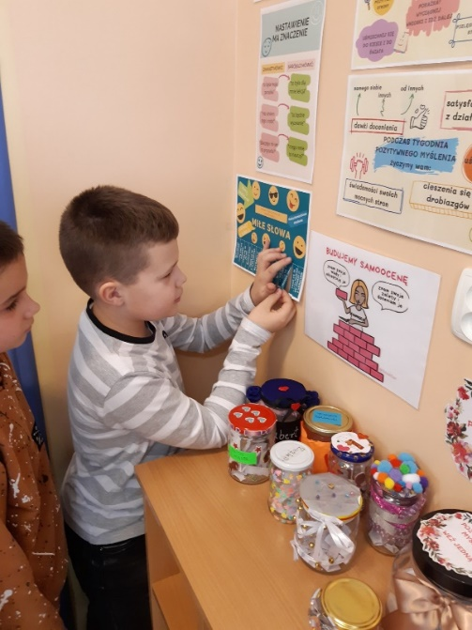
https://spborowa.edupage.org/news/?eqa=d2lkPW5ld3NfTmV3c18xX3AmbmV3c2FyY2hpdmVmPTIwMjItMDMmb2Zmc2V0X25ld3NfTmV3c18xX3A9MA%3D%3D#photos:album:1683

ZAJĘCIA POZALEKCYJNE Z WYCHOWANIA FIZYCZNEGO

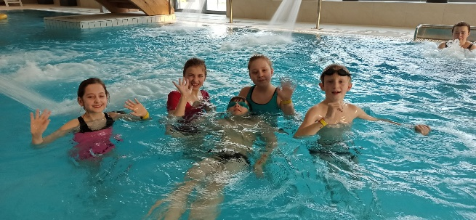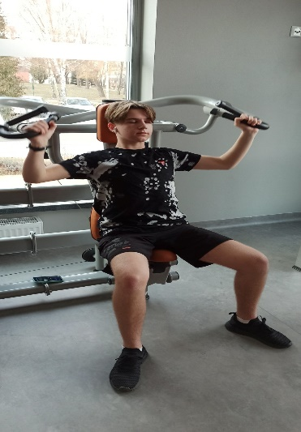
https://cloud5b.edupage.org/cloud?z%3A2svDKzuJ48G576VbpghvU0N2wk4b6gjhNxq8b%2FMhKVzbpMNw3OeGiZtj%2BT0ST%2BZi

WYJAZD NA LODOWISKO DO DĘBICY

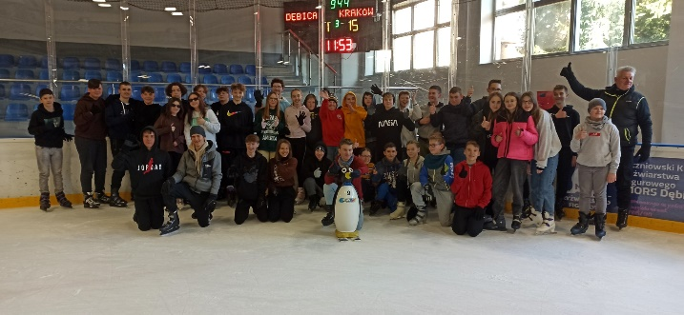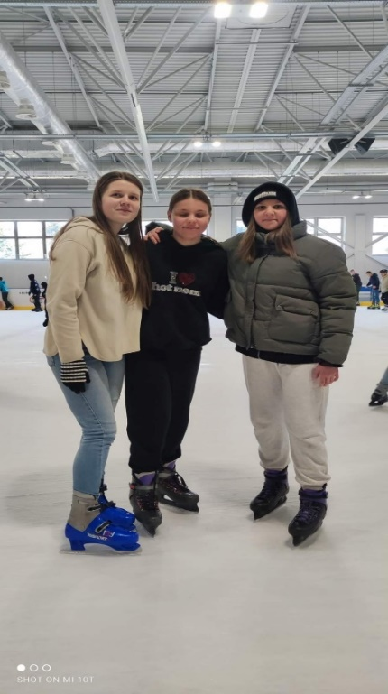

https://cloud2b.edupage.org/cloud?z%3AWr4lCE0Dymt%2B1Ai0VFVYZ52b4ujtyuE2Av1HsuIlrbI7Ei3c1OVkLvVbPsCPhq7w

ZIELONY OGRÓDEK NA PARAPECIE

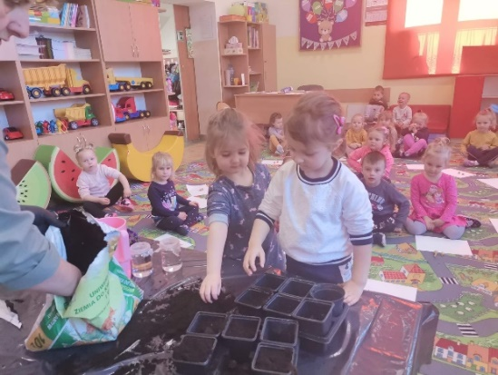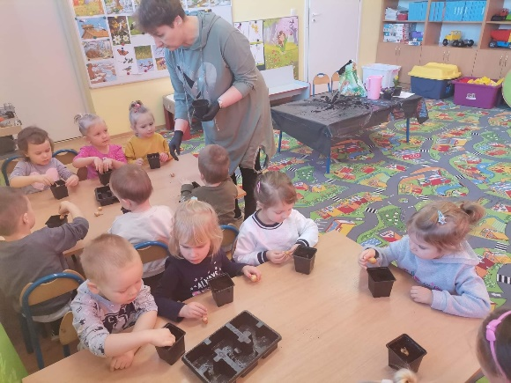

https://cloud5b.edupage.org/cloud?z%3A2SKTQAM6ieh7RmnD3LgePUpB21OcTfQq1BLpSVKk11ZL57jIijgSyx5XJ3pNKY4K
WARSZTATY ROWEROWE W MUZEUM

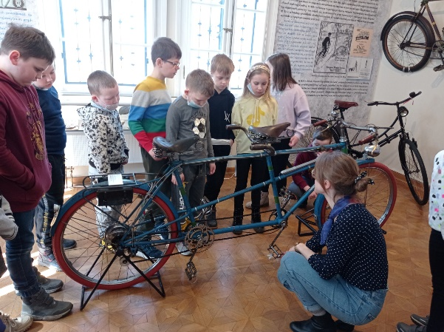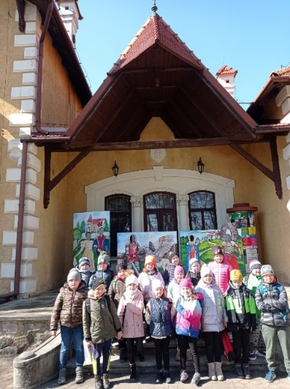

https://cloud2b.edupage.org/cloud?z%3A96NGaYj811apZ1uC4GXEdYwezq%2FSVEde97za6R24SRZqXuX4uJC0hr8xWM4XzrYg

WIOSENNE OBSERWACJE KLASY 2 A

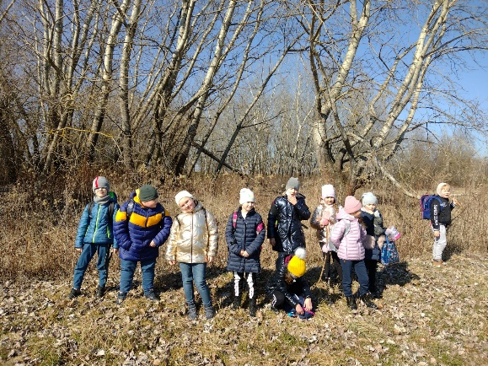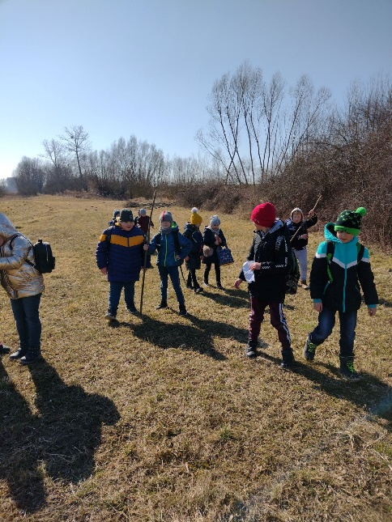

https://spborowa.edupage.org/news/?eqa=d2lkPW5ld3NfTmV3c18xX3AmbmV3c2FyY2hpdmVmPTIwMjItMDMmb2Zmc2V0X25ld3NfTmV3c18xX3A9MA%3D%3D#photos:album:1698

PRZEDSZKOLAKI WITAJĄ WIOSNĘ

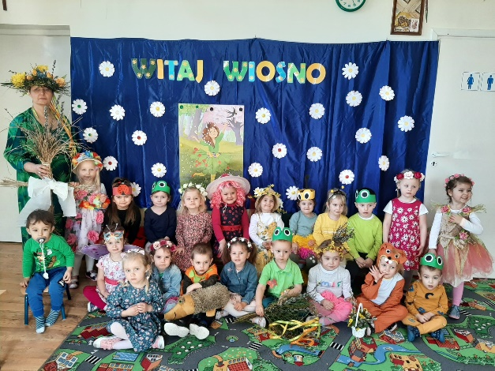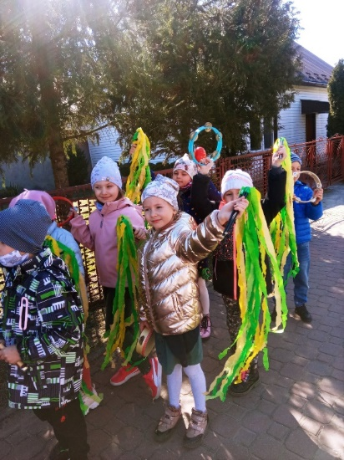

https://cloud7b.edupage.org/cloud?z%3ASKuvFWHXSH1O88Li4YUCgwdrEsuh6fRCfOTE4ASeMmxSwRBxluo9zeglzd67GAN3

„JAŚ I MAŁGOSIA” W SCK W MIELCU

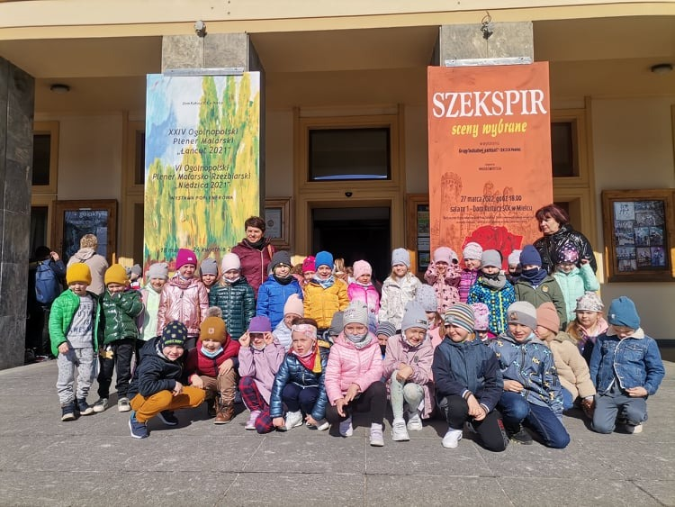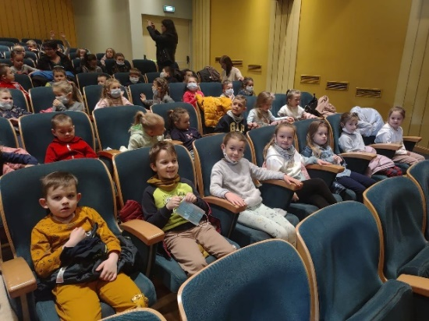

https://cloud7b.edupage.org/cloud?z%3AeS7dAOIaMhRTBNs6FA5XxpM9Q3LtrDodpPBMRnxX6tZ8qUX1ND5nAJx1YTwfFLBx

ZIELONY DZIEŃ W IIb

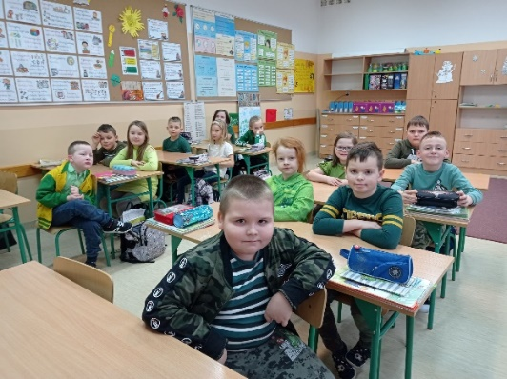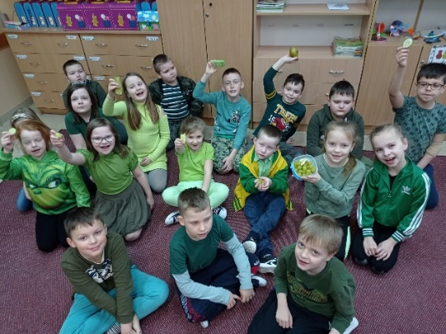

https://www.facebook.com/Szko%C5%82a-Podstawowa-Borowa-103319884856629/photos/pcb.472350941286853/472350814620199

HASZTASZKI

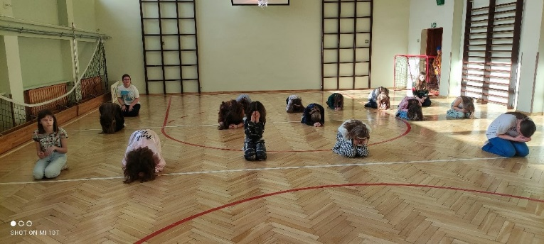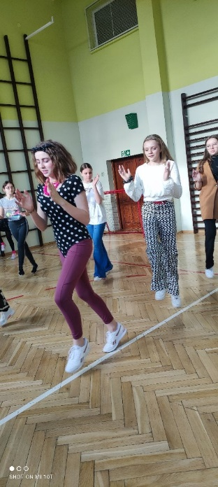

https://www.facebook.com/Szko%C5%82a-Podstawowa-Borowa-103319884856629/photos/pcb.472476721274275/472476384607642

WIOSENNY KONCERT MOBILNEJ FILHARMONII

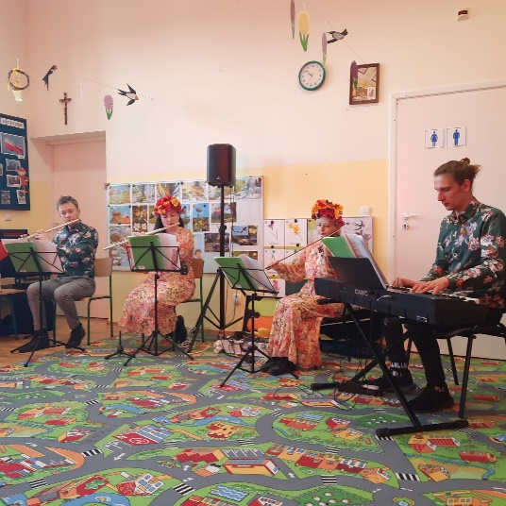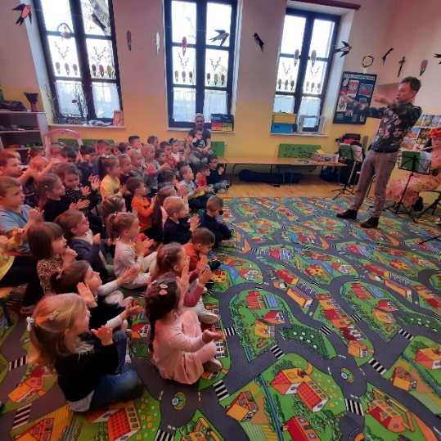

https://www.facebook.com/Szko%C5%82a-Podstawowa-Borowa-103319884856629/photos/pcb.475622544293026/475622374293043

ŚWIATOWY DZIEŃ ZESPOŁU DOWNA KOLOROWYCH SKARPETEK

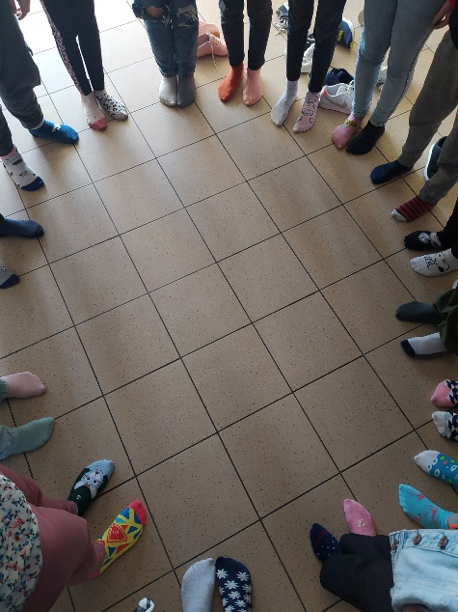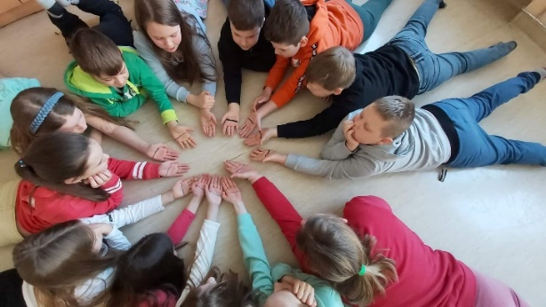

https://www.facebook.com/Szko%C5%82a-Podstawowa-Borowa-103319884856629/photos/pcb.479812023874078/479810843874196

MIĘDZYNARODOWY DZIEŃ GOFRA W VIA
KOLOROWYCH SKARPETEK

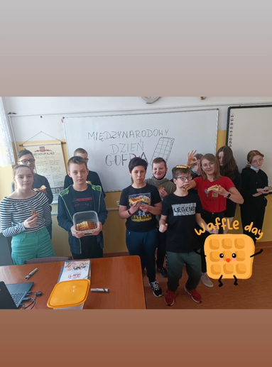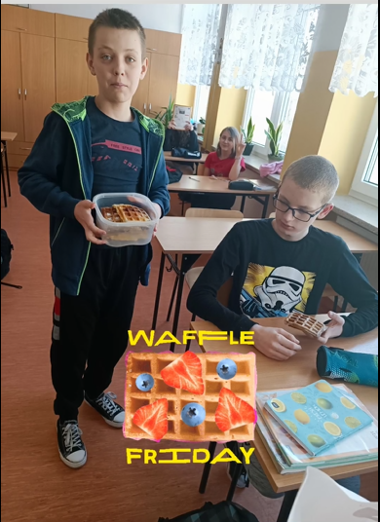
https://www.facebook.com/Szko%C5%82a-Podstawowa-Borowa-103319884856629/photos/pcb.481085823746698/481085727080041

HASZTAKI W ROZGRYWKACH PAINTBALL

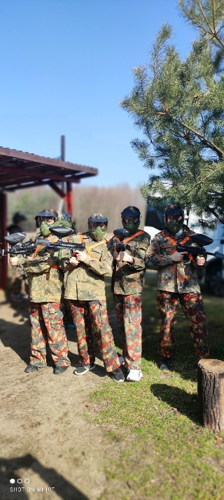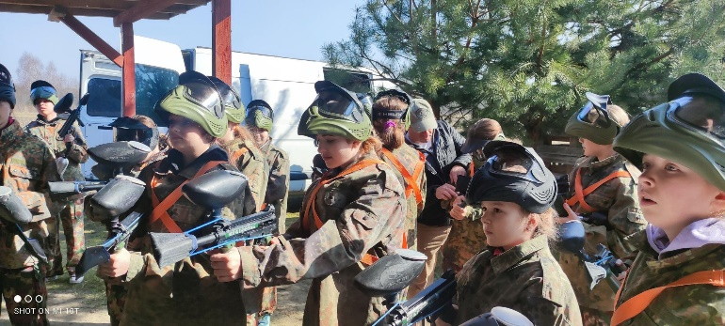

https://www.facebook.com/Szko%C5%82a-Podstawowa-Borowa-103319884856629/photos/pcb.481090363746244/481089580412989

